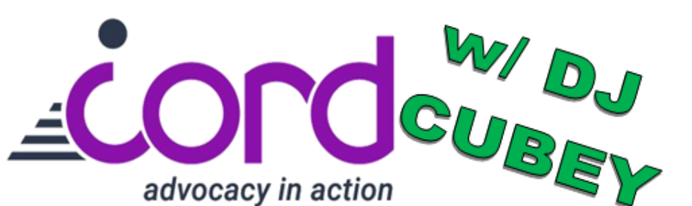
CORD’s
Music Bingo Fundraiser!
DATE: Thursday December 10, 2026  TIME: 6:30pm-8:30pm  PLACE: Courtyard by Marriott Cape Cod  707 Iyannough Rd, Hyannis, MA | 
Become a Sponsor or Donate!
Use this QR Code or complete  the form on the back!  *To be included in the program  book, your sponsorship must be in  by November 19, 2026   | 

CORD’s Sponsorship Packages
Sponsorship  Level | Number  Available | Donation  Amount | Ad in  our  program  book | Guest  Speaker  on Mic | Social  Media  Shout-  Outs | Free  Tickets  to Play | Additional  Tickets at  Discount | Sign at  Event
Spotlight | 1 | $10,000 | Inside  front  cover  and  outside  back | 5  minutes | ✓ | 14 | $10 | ✓
Blue  Diamond | 1 | $5,000 | Inside  back  cover |  | ✓ | 10 | $10 | ✓
Diamond | Unlimited | $3,500 | Full  page |  | ✓ | 8 | $15
Emerald | Unlimited | $2,500 | Half  page |  | ✓ | 6 | $15
Ruby | Unlimited | $1,500 | Half  page |  | ✓ | 4 | $15
Sapphire | Unlimited | $1,000 | Quarter  page |  | ✓ | 2 | $20
Supporter | Unlimited | $500 | Listing |  | ✓ | 1 | $20

Can’t sponsor, but still want to help? Make a donation!
$400 ____ | $300 ____ | $200 ____ | $100 ____ | Other $____________

Name of Business:
Name of Donor (First and Last):
Mailing Address:
Phone Number:
Checks can be made payable to CORD. Mail paper copy of Sponsor and Donor Form payment to
CORD at 765 Attucks Lane, Hyannis MA 02601
Or pay online and submit digitally using the QR code on the front of this form
*All Sponsorship and Donations Due November 19, 2026
Questions or concerns? Please contact CORD at 508-775-8300
or cordinfo@cilcapecod.org
CORD is a non-profit 501(c)(3) tax exempt organization and does not charge a fee for its services.
Donations and sponsorships may be tax deductible as allowed by law. Tax ID # 04-2901347

